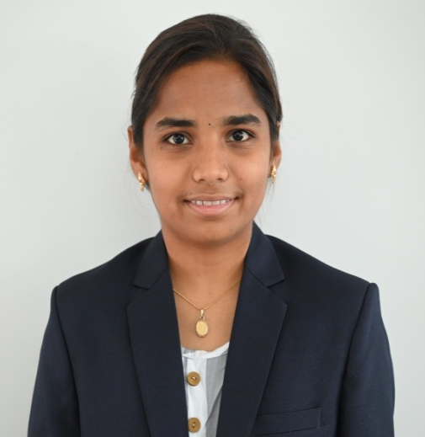




Education

Bachelor’s Degree
B.Sc (Hons) Agriculture
Kumaraguru Institute of Agriculture, Erode. (Affliated to TNAU) Passed out in the year 2022 with
7.9 % of OGPA

Higher Secondary
Government Higher Secondary School, Velalarivelli. Passed out in 2018 with 83% of marks.

SSLC
Govt Girls Higher Secondary School, Tiruchengode, Passed out in 2016 With 93% of marks.

languages known
Tamil
English
Telugu

6374064736
Kasthuri28sri@gmail.com
D.Kasthuri D/O Duraisamy
49, Vellalapatti, Suriyampalayam (PO), Tiruchengode (TK), Namakkal (DT) - 637209

Contact

KASTHURI
B.Sc (Hons) Agriculture

Professional overview

Dedicated field-level professional with experience working closely with rural communities. I serve as a bridge between farmers and essential resources, offering practical guidance on crop management, resource access, and sustainable agricultural practices.

Work experience

CFL Coordinator,Paramathi.

DHAN Foundation, Madurai

Working Under Center For Finanacial Literacy (RBI Project) for Two Years and Half Years in Paramathi, Kabilarmalai, Elachipalayam Block of Namakkal District.
- To create Awareness about Banking Products and Services.
- Act as a link between Rural Peoples and Banking Institutions.
- Involved in Finanacial Inclusion Activities and Rural Development and SHG linkage Activities.
- To support financial inclusion in underserved areas.

Projects Worked
- Value Chain of Turmeric – Analyse production and Market Linkage of Farmers Around in Erode District.
- Soil Resource Map of north & South Farm of KIA campus Around 103 Acres.
- RAWE (Rural Agricultural Work Experience) Stayed 6 month in Gobichettipalayam Village and learned field level problems with the Support with Assistant Director of Agriculture conduct many demonstrations and Organise Village level farmers meet.

STRENGTH and skills
- Organizing Field Level meetings.
- Strong Communication Skills.
- Good Driving Skill.
- Leadership Skills & Presentation Skill.
- Field Data Collection and Analysis of data.
- Data Reporting & Maintain the Records.
- Excellence in MS Word, EXCEL, Power point presentation and Other Tools.
- Collection and analysis of Soil, water and Plant Samples.

